Register No.

SRM UNIVERSITY, FACULTY OF ENGINEERING AND TECHNOLOGY
DEPARTMENT OF INFORMATION TECHNOLOGY

CYCLE TEST-2
(Academic Year : 2016-17 Even Semester)
15CS204J- ALGORITHM DESIGN AND ANALYSIS

Program offered :B.Tech(IT) Year / Sem: II/IV Date : 27-April-2017
Time : 3 Hours Max. Marks:100

Instructional Objectives
IO–No. | Instructional Objective | Student Outcome
1 | To apply divide and conquer method to solve a problem | i
2 | To solve a real life problems with these algorithmic techniques | i
3 | To familiarize the concept of multidisciplinary functions | i
4 | To interpret data using NP problems and applications of algorithms to solve real life problems | i

Student Learning Outcomes
LO–No. | Instructional Objective
i | An ability to use current techniques, skills, and tools necessary for computing practice
i1 | An ability to understand current techniques and skills
i2 | An ability to understand tools necessary for computing practice

Q. No. | Answer | Ref. to IO | Ref. to LO | Marks Scored  (1 Mark) | LO Met Y/N
1 |  | 3 | i1
2 |  | 2 | i2
3 |  | 1 | i1
4 |  | 2 | i2
5 |  | 4 | i1
6 |  | 1 | i1
7 |  | 1 | i1
8 |  | 2 | i2
9 |  | 2 | i2
10 |  | 2 | i2
11 |  | 2 | i2
12 |  | 5 | i1
13 |  | 5 | i1
14 |  | 3 | i1
15 |  | 5 | i1
16 |  | 2 | i2
17 |  | 2 | i2
18 |  | 3 | i1
19 |  | 2 | i2
20 |  | 1 | i1
Q. No. | Ref. to IO | Ref. to LO | Marks Allotted | Marks Scored | LO Met Y/N
Part-B Questions
21 | 2 | i2 | 4
22 | 1 | i1 | 4
23 | 5 | i1 | 4
24 | 5 | i2 | 4
25 | 2 | i2 | 4
26 | 4 | i1 | 4
27 | 4 | i2 | 4
Part-C Questions
28a | 1 | i1 | 12
28b | 1 | i1 | 12
29a | 4 | i1 | 12
29b | 4 | i1 | 12
30a | 4 | i1 | 12
30b | 4 | i1 | 12
31a | 3 | i2 | 12
31b | 3 | i2 | 12
32a | 5 | i2 | 12
32b | 5 | i2 | 12
Total Marks Scored

Faculty In-charge Signature

PART A ( 20 x 1 = 20 Marks) Answer ALL Questions
Answer Part-A in a Evaluation Sheet (First page of Question Paper)
- Suppose the letters a,b,c,d,e have probabilities 0.3,0.3,0.2,0.1,0.1 respectively. Which of the following is the Huffman code for the above letters?
[A] 100,110,00,10,01 [B] 10,11,00,010,011 [C] 100,110,11,10,11 [D] 10,111,00,01,01
- Which of the following standard algorithm is not a greedy algorithm?
[A] Dijkstra’s shortest path [B] Prim’s algorithm [C] Huffman Coding [D] Bellman ford shortest path
3. The time complexity of travelling salesman problem using dynamic programming is
[A] Ɵ( n!) [B] Ɵ (n²2^{n} ) [C] Ɵ (2^{n-1}) [D] Ɵ (n^{2n})
4. We use dynamic programming approach because
[A] The solution has optimal substructure [B] It provides optimal solution
[C] The given problem can be reduced to the 3-SAT problem [D] It is faster than greedy
5. The minimum number of edges in a Minimum cost spanning tree of a connected graph with ‘n’ vertices is
[A] n [B] n+1 [C] n-1 [D] 2n-1
6. In the forward computation method of multistage graph, the decision x_{i} is made in terms of the optimal decisions ___
[A] (x_{i-1},x_{i-2},… …, x₁) [B] (x₁,x₂,… …, x_{i-1}) [C] (x_{i},x_{i/2},… …, x₁) [D] (x₁,x₂,… …, x_{i/2} , x_{i})
7. Consider a knapsack of size 15. The profits of 3 items are (24,18,20) and the weights of 3 items are (8,9,5). What will be the profit earned in greedy knapsack?
[A] 48 [B] 44 [C] 42 [D] 52
8. A graph is said to be ____ iff it can be drawn in a plane in such a way that no two edges cross each other
[A] Complete [B] Clique [C] Isomorphic [D] Planar
9. ____ is a path in which the first and the last vertices are same.
[A] cycle [B] regular graph [C] multi-graph [D] Clique
10. A search technique where we keep expanding nodes with least accumulated cost so far is called
[A] Hill climbing [B] Backtracking [C] Branch and bound [D] Depth first search
11. Which term refers to All state space search methods in which all children of the e-node are generated before any other live node can become the e-node
[A] Dynamic programming [B] Branch and bound [C] Lower bound theory [D] Backtracking
12. Assuming P!=NP, which of the following is true?
[A] NP-Complete = NP [B] NP-Hard=NP [C] NP-Complete=P [D] NP-Complete ∩ P=Φ
13. Let X be a problem that belongs to the class NP. Then which one of the following is true?
[A] There is no polynomial time algorithm for X [B] If X is NP-hard, then it is NP-Complete
[C] If X can be solved deterministically in polynomial time, then P=NP [D] X may be un decidable
14. How many minimum-cost spanning trees are possible when each edge in the graph is assigned a different weight?
[A] 0 [B] 1 [C] 2 [D] many
15. Which of the following algorithm gives different result for a fixed input?
[A] Deterministic [B] NP-Complete [C] Randomized [D] Polynomial time
16. Back tracking technique uses ______ search
[A] Binary Search [B] Brute force Search [C] Depth first search [D] Breadth First Search
17. A node that is under construction in a state space tree is called
[A] Answer state [B] Live node [C] Dead node [D] E-node
18. How many solutions are possible for a 8 Queen problem?
[A] 8² [B] 8! [C] 8 [D] 1
19. A cycle is called _______ if it visits all vertices and returns back to the starting vertex.
[A] Chordless cycle [B] Hamiltonian [C] Peripheral cycle [D] Girth
20. Given 4 items with their weights w_{i}={11,12,13,23} and a positive integer W=36. How many solutions are possible for the given sum-of-subset problem?
[A] 1 [B] 2 [C] 3 [D] 4
.
.
.
PART –B (5 x 4 = 20 Marks)
Answer ANY 5 Questions
21. Illustrate greedy knapsack problem with an example
22. Color the following graph using graph coloring algorithm. What is the minimum number of colors required?

23. Distinguish between randomized and deterministic algorithm.
24. What is NP-Hard problem? How to handle NP-hard problems to find solution?
25. Write the procedure to solve matrix chain multiplication problem.
26. Compare brute-force method and backtracking method of generating permutations.
27. Explain the general method of backtracking technique.

PART –C (5 x 12 = 60 Marks)
Answer ALL Questions
28. a) Compute the minimum cost spanning tree for the graph of the following figure using
i. Kruskals algorithm ii. Prims algorithm

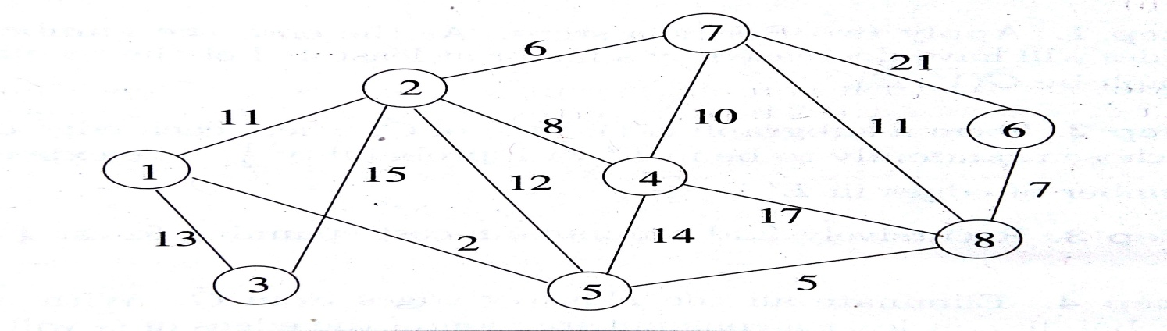

(OR)
b) Find a minimum cost path from ‘s’ to ‘t’ in the multistage graph for the following figure. Do this using
i. Forward approach ii. Backward approach

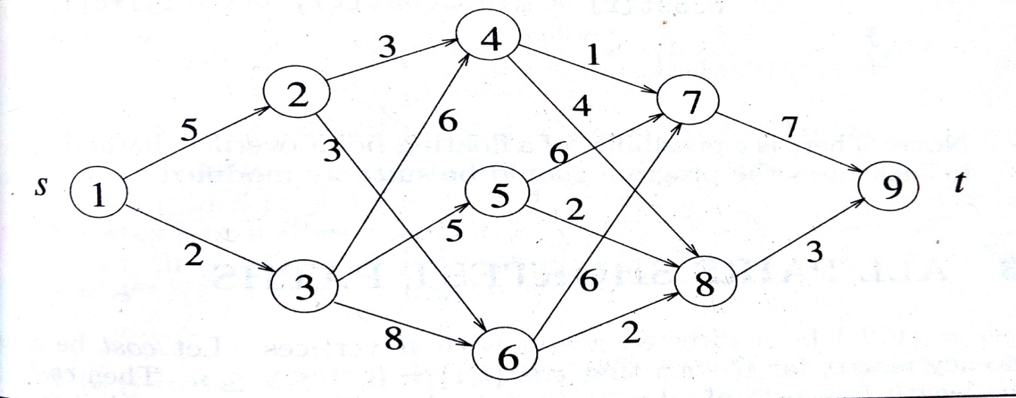

29. a) Device an algorithm to compress the given text using Huffman Coding with Greedy technique
(OR)
b) Write and analyze algorithm for n-queen problem using backtracking technique

30. a) Write backtracking algorithm for the sum of subset problem using the state space tree corresponding to the variable tuple size formulation
(OR)
b) Devise and algorithm to find all the Hamiltonian cycles of a graph. The graph is stored as an adjacency matrix G[1:n][1:n] and all cycles begin at node 1.

31. a) Consider the travelling salesperson instance defined by the cost matrix

α 2 3 4
1 α 4 3
2 3 α 4
4 3 2 α

Solve this problem using branch and bound technique. Generate state space tree for the solution.
(OR)
b) Solve the following travelling salesperson problem using dynamic programming method. The cost matrix is given below.

0 10 15 20
5 0 9 10
6 13 0 12
8 8 9 0

32 a) Write and explain the algorithm for Randomized quick sort. Compare randomized quick sort with divide and conquer quick sort method
(OR)
b) (i) Write a randomized algorithm for hiring problem
(ii) Analyze the complexity of randomized hiring problem

